**CHAPTER THREE**

**ANALYSIS AND DESIGN**

**3.1    Analysis of the Existing System**

In this part of the world (Nigeria) the existing system for managing depression is still the use of human experts, this requires interactions between therapist and patience either directly in the same physical location or through mediums like video call, chat rooms, telephone calls and so on. The therapist ask the patience questions related to their symptoms gets feedback from the patience then make a diagnosis of the type of depression and make appropriate prescription, this system is effective in regions with adequate exposure to health education about depression and facilities, but less effective in region where people are less informed about depressive symptoms. Hence the need for a different approach .

**3.1.1    Advantages of the Existing System**

The current system of student hostel allocation do have some advantages and they are:

1. The system does the job of allocating students to hostels based on availability.
2. The system ensures that each room is filled first before allocation to another room is started.
3. The system keeps track of the number of hostels available for both category of students (male and female) and also keeps track of the number of hostels available for both.
4. It allows the student affairs division to have a proper statistics of student allocation which aids in resource distribution to these hostel facilities.

**3.1.2    Disadvantages of the Existing System**

The weakness of the existing system includes:

1. In computing terms, the allocation process is of the order of O(n), which implies that the if we have say 1000 students, it takes us 1000 computational time to fill up the rooms. Each room in an hostel can be modelled as an array. Just as an array has better approaches to reduce the computational time, therefore the allocation process can be done optimally using genetic algorithm as a the focal point.

**3.2    Analysis of the Proposed System**

The proposed system for student hostel allocation utilizes Genetic Algorithm to optimize the allocation process and also reduce the computational time it takes to allocate students to hostels. Allocations of male and female students into hostels are done in a mutually exclusive manner as undergraduate hostels are delineated based on gender. From the dataset available, there are ten on-campus residences with six designated for male and four for females respectively. Usually, residences are built as multi-story structures (with the exception of two hostel) each with varying numbers of floors that are further divided into blocks (otherwise call wings). Rooms are located on each wing per floor with each having one or more beds depending on the number of students it is designed to accommodate. Usually, due to the shortage of space, most rooms are designed to take more than one student and students on each wing have access to common facilities such as toilets and baths. The university, through the office of students’ affairs, sets the criteria that make a student eligible for a bed space and each eligible student is entitled to only one bed space. The eligibility criteria may vary and is manually checked by staff.

1. Final Year Students (Fy): Those in the last year of study

2. Scholars (Sc): Students with cumulative grade point averages that are in the first class range.

3. Foreign Students (Fo): whose nationality and residence is not Nigeria.

4. Health Students (Ht): Physically challenged students.

5. Fresher (Fr): First year and direct-entry students.

6. Sports students (Sp): Male and Female students who participate in sporting activities at the university.

7. Discretionary (Ds): Students considered based on special requests

8. Others (Ot): All other students requiring accommodation (in various years of study).

Each category of students has peculiar characteristics and requirements which can be factored in as constraints into the allocation process. For example, disabled (health) students cannot be given allocation on the top floor in any residence since none of the hostels is built with escalators for ease of movement for them. Moreover, since the space available is limited, some of the categories are prioritized based on pre-set administrative and/or other considerations. This serves as a major hard constraint during category allocation. Other administrative considerations that serve as either hard or soft constraints include:

1. First year students must be allocated to a floor that will afford them less distractions (soft).
2. Health students must be accommodated in hostels close to the medical centers and on the lowest floor for easy access (hard);
3. Sport students must be accommodated close to sports facilities due to practice (hard);
4. All First year, Foreign and Health students should be accommodated (hard).

**3.3    Methodology**

The methodology adopted for the development of this system is the object oriented analysis and design methodology. In this system we shall consider several modules that would be plugged together to give the system its full functionality. System design specifies how the system will accomplish the set objectives. This stage comprises design activities that produce system specifications satisfying all the functional requirements. Use case diagrams are adopted to model various activities and scenarios in the proposed system.

**3.4    System Design**

The design of the proposed system is shown in figure 3.1. The students are categorized and for first year students, health students and foreign students are categorized as fixed allocations while others are categorized as flexible allocations. Then for fixed allocations, we allocate all of them while for the flexible allocations, we utilize a priority based allocation to the students. The total number of students are the population in the genetic algorithm system and as the system evolves, mutation sets in and we can compute the fitness function from there.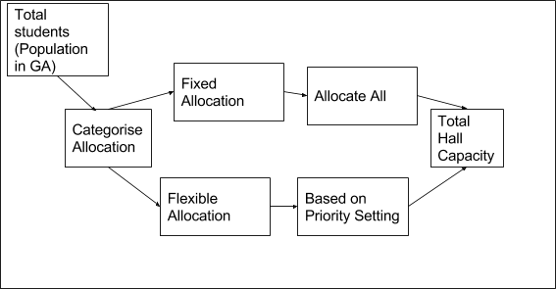

**Fig 3.1 Design of proposed system**

**3.5    Use Case Diagram**

The use case diagram of the proposed system is shown in figure 3.2. It shows the process the user takes to allocate hostels to students. The admin inputs students databased on the categorized earlier mentioned. With the click of a button the admin clicks on optimize using GA and the genetic algorithms performs the function of allocating the students to the hostels by evolving the population of students.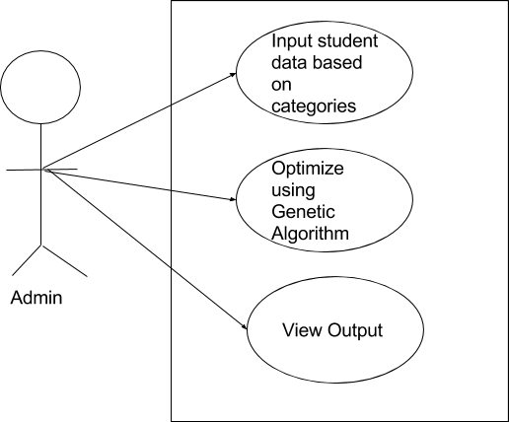

Fig 3.2 Use case Diagram for Student Allocation

**3.6 Software Requirements**

1. Operating system- Windows and mobile operating system is used as the operating system as it is stable and supports more features and is more user friendly.
2. Database MYSQL-MYSQL is used as database as it easy to maintain and retrieve records by simple queries which are in English language which are easy to understand and easy to write.
3. Development tools and Programming language- HTML and is used to write the whole code and develop webpages with cascading style sheet, bootstrap and java script for manipulating the document object model(DOM) and hypertext pre-processor (PHP) for sever side scripting.

**3.6.1 Software tools used**

The whole Project is divided in two parts the front end and the back end.

**FRONT END:** The front end is designed using of HTML, Bootstrap, CSS, Java script

1. **HTML**- HTML or Hyper Text Mark-up Language is the main mark-up language for creating web pages and other information that can be displayed in a web browser.HTML is written in the form of HTML elements consisting of tags enclosed in angle brackets (like <html>), within the web page content. The purpose of a web browser is to read HTML documents and compose them into visible or audible web pages. It provides a means to create structured documents by denoting structural semantics for text such as headings, paragraphs, lists, links, quotes and other items. It can embed scripts written in languages such as JavaScript which affect the behaviour of HTML web pages.
2. **CSS**- Cascading Style Sheets (CSS) is a style sheet language used for describing the look and formatting of a document written in a mark-up language. While most often used to style web pages and interfaces written in HTML and XHTML, the language can be applied to any kind of XML document, including plain XML, SVG and XUL. CSS is a cornerstone specification of the web and almost all web pages use CSS style sheets to describe their presentation.CSS is designed primarily to enable the separation of document content from document presentation, including elements such as the layout, colours, and fonts. It can also be used to allow the web page to display differently depending on the screen size or device on which it is being viewed.
3. **JAVA SCRIPT**- JavaScript (JS) is a dynamic computer programming language. It is most commonly used as part of web browsers, whose implementations allow client side scripts to interact with the user, control the browser, communicate asynchronously, and alter the document content that is displayed. It is also being used in server-side programming, game development and the creation of desktop and mobile applications. JavaScript is a prototype-based scripting language with dynamic typing and has first- class functions. Its syntax was influenced by C. JavaScript copies many names and naming conventions from Java, but the two languages are otherwise unrelated and have very different semantics. The key design principles within JavaScript are taken from the self and Scheme programming languages. It is a metaparadigm language, supporting object-oriented, imperative, and functional programming styles.
4. **Bootstrap is a touch-optimized HTML5 UI framework designed to make responsive web sites and apps that are accessible on all screen sizes including smartphone, tablet and desktop devices.**

**BACK END-** The back end is designed using MySQL which is used to design the databases and PHP which is a scripting language for server side.

1. **MYSQL**- MySQL ("My S-Q-L", officially, but also called "My Sequel") is (as of July 2013) the world's second most widely used open-source relational database management system (RDBMS). It is named after co-founder Michael Widenius daughter, My. The SQL phrase stands for Structured Query Language. The MySQL development project has made its source code available under the terms of the GNU General Public License, as well as under a variety of proprietary agreements. MySQL was owned and sponsored by a single for- profit firm, the Swedish company MySQLAB, now owned by Oracle Corporation. MySQL is a popular choice of database for use in web applications, and is a central component of the widely used LAMP open source web application software stack (and other 'AMP' stacks). LAMP is an acronym for "Linux, Apache, MySQL, Perl/PHP/Python." Free-software-open source projects that require a full-featured database management system often use MySQL. For commercial use, several paid editions are available, and offer additional functionality. Applications which use MySQL databases include: TYPO3, MODx, Joomla, WordPress, phpBB, MyBB, Drupal and other software. MySQL is also used in many high-profile, large-scale websites, including Wikipedia, Google (though not for searches), Facebook, Twitter, Flickr, and YouTube.
2. **PHP**- PHP is a server-side scripting language designed for web development but also used as a general-purpose programming language. PHP is now installed on more than 244 million websites and 2.1 million web servers. Originally created by RasmusLerdorf in 1995, the reference implementation of PHP is now produced by The PHP Group. While PHP originally stood for Personal Home Page, it now stands for PHP: Hypertext Pre-processor, a recursive backronym.PHP code is interpreted by a web server with a PHP processor module, which generates the resulting web page: PHP commands can be embedded directly into an HTML source document rather than calling an external file to process data. It has also evolved to include a command-line interface capability and can be used in standalone graphical applications. PHP is free software released under the PHP License. PHP can be deployed on most web servers and also as a standalone shell on almost every operating system and platform, free of charge.

**3.7 Hardware Requirements**

A laptop, desktop, tablet or mobile device with at least 1gigabyte RAM and a functioning web browser e.g. Firefox and Chrome.